IILM UNIVERSITY
INTERNSHIP / TRAINING REPORT
Backend Development (Node.js) Internship at UpStartInterns
Submitted in partial fulfillment of the requirements of the University
Student Name | Rishabh Gupta
Roll Number | 25SCS1003000781
Programme | B.Tech CSE
Section | 2CSE19
Semester | 3
Training Organization | UpStartInterns
Training Mode | Online / Remote
Training Duration | 25 October 2026 to 24 November 2026*
Academic Year | 2026–27
*Dates reproduced from the main UpStartInterns certificate image. Please verify the date discrepancy noted in the report before
final university submission.

CANDIDATE'S DECLARATION
I, Rishabh Gupta, student of B.Tech Computer Science and Engineering, Semester 3, IILM University,
hereby declare that this internship/training report titled “Backend Development (Node.js) Internship at
UpStartInterns” has been prepared by me for academic purposes.
This report summarizes the learning activities, practical exercises, technical concepts, and project tasks
associated with the backend development training. The descriptions are based on the internship task
requirements and the work and learning activities discussed during the training.
I have made efforts to present the information accurately. Any information obtained from external
technical documentation has been acknowledged in the references section. I understand that the report
should be checked against the final task submissions and official internship records before it is submitted
to the University.
Student Signature: ______________________________
Name: Rishabh Gupta
Date: __________________
IILM University | Backend Development Internship Report Page 2

ACKNOWLEDGEMENT
I would like to express my sincere gratitude to IILM University, the Department of Computer Science and
Engineering, and my faculty members for providing me with the opportunity to undertake internship
training in Backend Development using Node.js.
I am thankful to UpStartInterns for providing a structured learning opportunity focused on practical
backend development. The sequence of tasks helped me understand how a server receives requests,
validates input, communicates with a database, and protects resources through authentication and
authorization.
I also appreciate the guidance and learning resources made available during the training. The exercises
encouraged me to practise writing API routes, handling errors, organizing database operations, and testing
secured endpoints.
Finally, I would like to thank my classmates, friends, and family for their encouragement and support
during the preparation of this report.
Student Signature: ______________________________
Rishabh Gupta
IILM University | Backend Development Internship Report Page 3

TABLE OF CONTENTS
Chapter / Section | Page
Project Description | 4
4.1 Introduction | 4
4.2 Organization Profile | 5
4.3 Problem Statement | 6
4.4 Project Objectives | 6
4.5 Scope of the Project | 7
4.6 Technologies and Tools Used | 8
4.7 System Architecture | 9
4.8 Methodology | 10
4.9 Expected Outcomes and Learning | 11
4.10 Certificate of Completion and Communication Proof | 12
Bibliography / References | 13
Note: Page numbers are based on this generated report. Update them if you make substantial edits.
IILM University | Backend Development Internship Report Page 4

PROJECT DESCRIPTION
4.1 INTRODUCTION
Backend development is the part of software development responsible for the server-side logic of an
application. It manages incoming requests, processes data, communicates with databases, applies business
rules, and sends responses to clients. A well-designed backend should be reliable, maintainable, secure,
and capable of handling invalid requests appropriately.
The internship focused on the fundamentals of backend development using JavaScript and Node.js.
Node.js provides a runtime environment for executing JavaScript outside the browser. Express.js can be
used with Node.js to create web servers and REST-style API endpoints.
The training was organized around progressive tasks: creating an HTTP server and routes, validating
request data and managing errors, integrating a database through migrations and parameterized queries,
and securing API endpoints using authentication and authorization concepts.
The report presents these activities as a learning-oriented backend project. It explains the problem being
addressed, the objectives, the technologies, a conceptual system architecture, the development
methodology, and the expected learning outcomes.
IILM University | Backend Development Internship Report Page 5

4.2 ORGANIZATION PROFILE
UpStartInterns is the organization named on the internship completion certificate supplied for this report.
The certificate identifies the training domain as Backend Development (Node.js) and the mode as Online /
Remote. The internship tasks were structured to provide practical exposure to common backend
engineering responsibilities.
The training structure progressed from foundational server development to validation, database operations,
and API security. This progression reflects a practical learning path in which each stage builds on the
concepts introduced in earlier tasks.
4.3 PROBLEM STATEMENT
Many applications require a backend service that can accept client requests, return consistent responses,
store information safely, and prevent unauthorized access. A basic server without validation or security can
accept incorrect data, expose implementation details through errors, or allow users to access resources that
do not belong to them.
The project therefore addresses the need to design and develop a structured backend API that supports
routing, input validation, centralized error handling, database integration, authentication, authorization, and
automated testing.
4.4 PROJECT OBJECTIVES
The main objectives were to:
• Create a server with multiple JSON endpoints and a suitable 404 response.
• Validate incoming request data and return clear client-safe error messages.
• Connect the application to a database using migrations, seed data, and parameterized queries.
• Apply token-based authentication and password hashing concepts.
• Restrict access so users cannot retrieve or modify another user's protected data.
• Write tests for successful and unsuccessful API operations.
IILM University | Backend Development Internship Report Page 6

4.5 SCOPE OF THE PROJECT
The scope of the internship project covers the design and implementation concepts required for a small,
secure backend API. It emphasizes the server-side components rather than the design of a complete
frontend application.
Included within the scope
• HTTP request handling and JSON responses.
• Route creation and handling of unknown routes.
• Request-body validation and consistent error responses.
• Database schema creation through migration files and sample-data seeding.
• Safe database access through parameterized queries.
• User authentication using tokens and securely hashed passwords.
• Authorization checks for user-specific resources.
• Automated tests for expected and failure scenarios.
Outside the defined scope
The report does not claim deployment to a production environment, large-scale performance
benchmarking, a complete graphical user interface, or integration with external commercial services unless
these were separately implemented and documented in the submitted repositories.
Project deliverables
The expected deliverables for the task sequence are source-code repositories, setup instructions in
README files, migration and seed scripts where applicable, and automated tests for the secured API. The
repositories should be checked to ensure that the final submitted versions match the work completed.
IILM University | Backend Development Internship Report Page 7

4.6 TECHNOLOGIES AND TOOLS USED
Technology / Tool | Purpose
JavaScript | Programming language used to write backend application logic.
Node.js | Runtime environment for executing JavaScript on the server.
Express.js / HTTP module | Creating the web server, routes, middleware, and JSON responses.
REST-style API | Organizing endpoints around HTTP methods and resources.
Database and migrations | Defining and updating the database schema in a repeatable way.
Parameterized queries | Passing values separately from SQL statements to reduce SQL-injection risk.
Token-based authentication | Verifying the identity of a user making a protected request.
Password hashing | Storing password-derived hashes instead of plain-text passwords.
Automated testing | Checking normal and error cases in API behavior.
Git and GitHub | Version control, source-code hosting, and repository documentation.
The exact package versions, database engine, test framework, and development environment should be copied from the final
project repositories and package configuration files. They are not assumed in this report.
IILM University | Backend Development Internship Report Page 8

4.7 SYSTEM ARCHITECTURE
The project follows a layered backend architecture. A client sends an HTTP request to the server. The
routing layer selects the relevant endpoint, middleware performs common checks such as parsing and
validation, and the controller or route handler applies the application logic. Where data is required, the
application communicates with the database through safe query operations. The server then returns a JSON
response to the client.
Client / API Request
HTTP Method + URL + JSON Body / Token
↓
Node.js Server and Express Routes
Routing • Middleware • Validation • Authentication
↓
Application / Business Logic
Authorization • Request Processing • Error Handling
↓
Database Layer
Migrations • Parameterized Queries • Seed Data
↓
JSON Response
Centralized error handling ensures that unexpected failures are converted into consistent responses without
exposing internal stack traces. Authentication confirms who the requester is, while authorization checks
whether that requester is permitted to access the requested resource.
IILM University | Backend Development Internship Report Page 9

4.8 METHODOLOGY
The internship tasks follow an incremental development methodology. Each task introduces a specific
backend responsibility, provides a focused implementation goal, and builds toward a more complete API.
Task 1 – HTTP Server and Routing
The first stage focuses on starting a Node.js server, defining at least three routes, returning JSON data, and
responding appropriately when a requested route does not exist. This establishes the basic request-response
cycle.
Task 2 – Validation and Error Handling
The second stage adds request-body validation and a centralized error-handling mechanism. Invalid
requests should receive suitable JSON error responses, while internal stack traces and sensitive
implementation details should not be sent to clients.
Task 3 – Database Integration and Migrations
The third stage introduces a real database, migration files, and a seed script. Parameterized queries are used
for database operations so that user-supplied values are not directly concatenated into SQL statements. The
application should be reproducible from a clean setup.
Task 4 – Secured API and Testing
The final stage applies token-based authentication, password hashing, and ownership checks. Tests should
cover successful operations as well as invalid credentials, missing data, unauthorized access, and other
failure paths. The test suite should work from a clean clone when the documented setup steps are followed.
Development cycle
Understand requirements →Design routes and data flow →Implement →Validate inputs →Test success
and failure cases →Document setup and usage →Review repository.
IILM University | Backend Development Internship Report Page 10

4.9 EXPECTED OUTCOMES AND LEARNING
The internship task sequence is intended to strengthen practical understanding of server-side application
development. By completing the stages, a learner should be able to explain how an API receives and
processes requests, how middleware supports reusable checks, and how consistent error responses improve
maintainability.
Technical learning outcomes
• Understanding the Node.js runtime and server-side JavaScript.
• Creating routes and returning structured JSON responses.
• Validating request data before processing it.
• Handling errors centrally and safely.
• Managing database schema changes with migrations.
• Using parameterized queries for safer database access.
• Understanding authentication, authorization, and password hashing.
• Writing automated tests for both successful and unsuccessful cases.
Professional learning outcomes
The work also encourages problem-solving, reading technical documentation, organizing code,
maintaining a GitHub repository, writing setup instructions, and breaking a larger task into smaller
milestones.
Challenges and ways to address them
Typical challenges in this type of work include understanding asynchronous JavaScript, choosing clear
route structures, validating edge cases, configuring a database from a clean environment, and testing
access-control rules. These challenges can be addressed through small implementation steps, clear error
messages, repeatable setup instructions, and tests that cover both permitted and prohibited actions.
Overall outcome
The task sequence provides a foundation for developing small backend services and for further study of
API design, databases, application security, and software testing. Final claims about implementation
should be supported by the corresponding source-code repositories and test results.
IILM University | Backend Development Internship Report Page 11

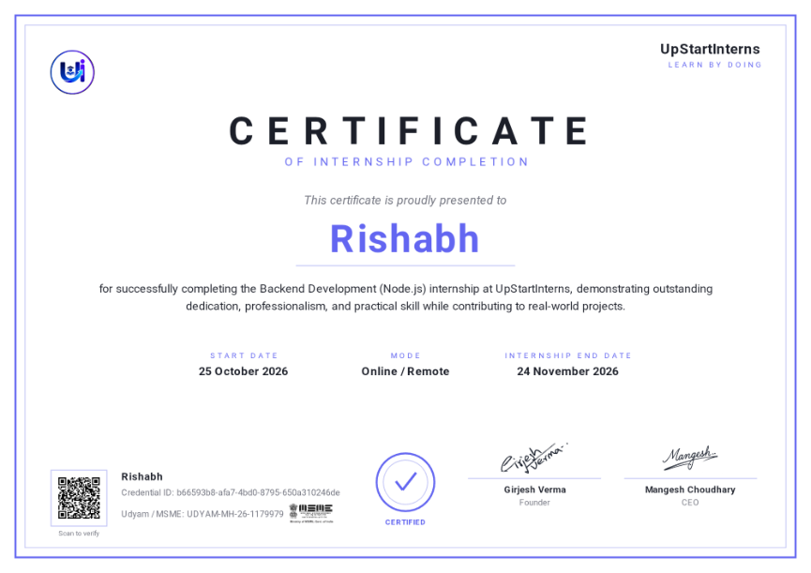

4.10 CERTIFICATE OF COMPLETION AND COMMUNICATION PROOF
The supplied UpStartInterns certificate identifies the trainee as Rishabh and the internship domain as
Backend Development (Node.js). It displays the mode as Online / Remote and lists the training period as
25 October 2026 to 24 November 2026.
Date verification note: One separate report-template screenshot contains a different training period (22
June 2026 to 11 July 2026) and a reference to a Deloitte certificate. Those details do not match the
UpStartInterns certificate and have therefore not been used as the internship dates or organization in this
report. Before university submission, verify the official dates and attach the correct original certificate.
Figure 1. UpStartInterns Backend Development (Node.js) internship certificate supplied by the student.
Communication proof: Attach relevant official emails, task-platform completion screenshots, submission
confirmations, or other genuine communication records here. No communication screenshots were
supplied with the material used to prepare this report; therefore, none have been fabricated.
IILM University | Backend Development Internship Report Page 12

BIBLIOGRAPHY / REFERENCES
1. Node.js Documentation, “About Node.js.” https://nodejs.org/en/about
2. Express.js Documentation, “Express – Node.js web application framework.” https://expressjs.com/
3. MDN Web Docs, “HTTP overview.” https://developer.mozilla.org/en-US/docs/Web/HTTP/Overview
4. | OWASP | Foundation, | “SQL | Injection | Prevention | Cheat | Sheet.”
https://cheatsheetseries.owasp.org/cheatsheets/SQL_Injection_Prevention_Cheat_Sheet.html
5. | OWASP | Foundation, | “Password | Storage | Cheat | Sheet.”
https://cheatsheetseries.owasp.org/cheatsheets/Password_Storage_Cheat_Sheet.html
6. GitHub Docs, “About repositories.” https://docs.github.com/en/repositories
7. UpStartInterns, Backend Development (Node.js) internship task instructions and completion certificate
supplied by the student.
End of Report
IILM University | Backend Development Internship Report Page 13

